1. phoenix.craiglist.org
2. [www.public.asu.edu/~kgary](http://www.public.asu.edu/~kgary)
3. www.mlbtraderumors.com

Craiglist :

This website is adaptive. It does not rearranges its content based of screen size but trys to adapt according to screen dimensions.

Here in craiglist website, content has to be accessed using horizontal scroll.

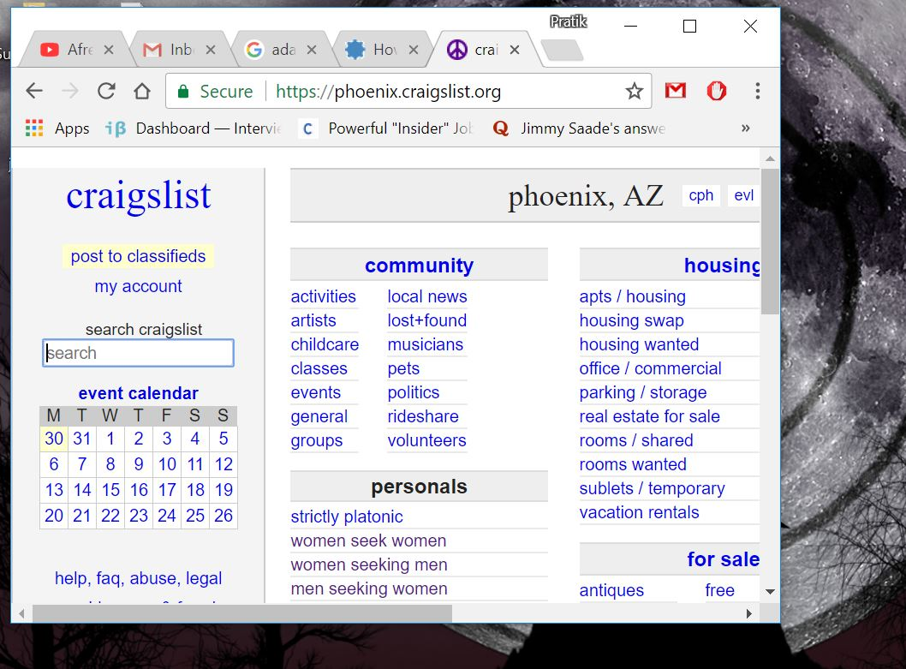

2. [www.public.asu.edu/~kgary](http://www.public.asu.edu/~kgary)

This is responsive website.

Since content is properly arranged upon change in screen size, all content looks same on different screens.

Different Components on web page are resized in proportion to screen size, hence no need of horizonal scrolling

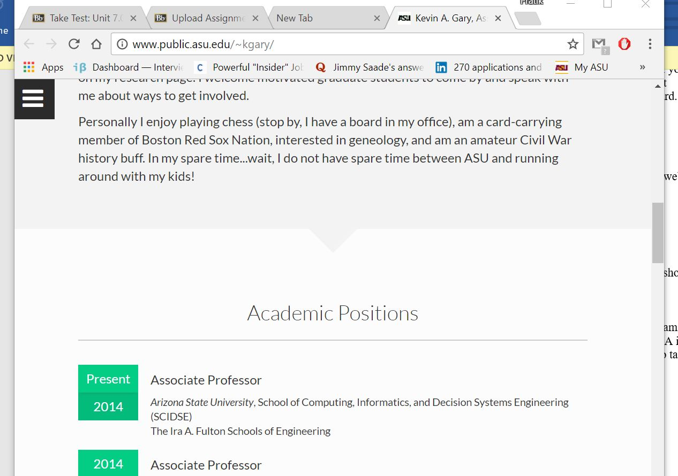

3. www.mlbtraderumors.com

This is again responsive website, all content is rearranged in ratio with screen size. Upon change in size, all content can be accessed without any horizontal scrolling.

